Full Stack Development with MERN
Project Documentation
HouseHunt - Rental Property Management System

1. Introduction
Project Title:
HouseHunt – Rental Property Management System
Team Members
Name | Role
Amith Koka | Full Stack Developer (Frontend, Backend, Database Integration, Testing & Documentation)

2. Project Overview
Purpose
HouseHunt is a MERN Stack based Rental Property Management System designed to simplify the process of listing, searching, and booking rental properties.
The application provides a centralized platform where:
- Property Owners can list and manage rental properties.
- Renters can search and book available properties.
- Administrators can manage users, properties, and bookings.
The project demonstrates complete full-stack development using React, Node.js, Express.js, and MongoDB.

Features
Admin Features
- View all registered users
- Approve owner accounts
- View all properties
- View all bookings
- Manage platform activities
Owner Features
- Owner Registration and Login
- Add New Property
- Upload Property Images
- Edit Property Details
- Delete Property
- View Booking Requests
- Accept or Reject Bookings
Renter Features
- Register and Login
- Browse Properties
- Search and Filter Properties
- View Property Details
- Book Properties
- Track Booking Status
General Features
- JWT Authentication
- Role-Based Access Control
- Property Image Upload
- Responsive User Interface
- MongoDB Database Integration
3. Architecture
Frontend Architecture
Technology Used:
- React.js
- React Router DOM
- Axios
- Tailwind CSS
- Ant Design
Frontend Responsibilities:
- User Interface Rendering
- Client-Side Routing
- Form Validation
- API Communication
- Property Listing Display
- Booking Management Interface
Modules:
- Admin Module
- Owner Module
- Renter Module
- Authentication Module

Backend Architecture
Technology Used:
- Node.js
- Express.js
Backend Responsibilities:
- REST API Development
- Authentication & Authorization
- Property Management
- Booking Management
- User Management
- File Upload Handling
Backend Components:
- Controllers
- Routes
- Middleware
- Models

Database Architecture
Technology Used:
- MongoDB
- Mongoose ODM
Collections:
Users Collection
Stores:
- User Name
- Email
- Password (Hashed)
- User Type
- Owner Approval Status
Property Collection
Stores:
- Property Type
- Property Ad Type
- Property Address
- Owner Contact
- Property Amount
- Property Images
- Additional Information
- Property Availability
Booking Collection
Stores:
- Property ID
- Owner ID
- User Details
- Booking Status

4. Setup Instructions
Prerequisites
Install:
- Node.js
- MongoDB Community Server
- MongoDB Compass
- Git
- VS Code

Installation
Clone Repository
git clone <repository-url>
Frontend Setup
cd Client/Frontend
npm install
Backend Setup
cd Server/Backend
npm install

Environment Variables
Create a .env file inside:
Server/Backend
Example:
PORT=8001
MONGO_URL=mongodb://127.0.0.1:27017/houserent
JWT_SECRET=your_secret_key
5. Folder Structure
VIP_C2_House_Rent_Amith_Koka
│
├── Client
│ └── Frontend
│ ├── public
│ ├── src
│ │ ├── images
│ │ ├── modules
│ │ │ ├── admin
│ │ │ ├── owner
│ │ │ ├── renter
│ │ │ └── common
│ │ ├── App.jsx
│ │ └── main.jsx
│ └── package.json
│
├── Server
│ └── Backend
│ ├── controllers
│ ├── middlewares
│ ├── models
│ ├── routes
│ ├── uploads
│ ├── config
│ ├── index.js
│ └── package.json
│
└── README.md
6. Running the Application
Start MongoDB
Ensure MongoDB service is running.
Connection URL:
mongodb://localhost:27017

Run Backend
cd Server/Backend
npx nodemon index.js
Expected Output:
MongoDB Connected Successfully
Server is running on port 8001
Backend URL:
http://localhost:8001

Run Frontend
cd Client/Frontend
npm run dev
Expected Output:
http://localhost:5173
Frontend URL:
http://localhost:5173

7. API Documentation
User APIs
Register User
POST /api/user/register
Login User
POST /api/user/login
Forgot Password
POST /api/user/forgotpassword
Get All Properties
GET /api/user/getAllProperties
Book Property
POST /api/user/bookinghandle/:propertyId

Owner APIs
Add Property
POST /api/owner/postproperty
Get Owner Properties
GET /api/owner/getallproperties
Update Property
PATCH /api/owner/updateproperty/:propertyid
Delete Property
DELETE /api/owner/deleteproperty/:propertyid
Get All Bookings
GET /api/owner/getallbookings

Admin APIs
Get All Users
GET /api/admin/getallusers
Get All Properties
GET /api/admin/getallproperties
Get All Bookings
GET /api/admin/getallbookings
Approve Owner
POST /api/admin/approveowner
8. Authentication
Authentication Mechanism:
- JWT (JSON Web Token)
- Cookies
- Protected Routes
Security Features:
- Password Hashing using Bcrypt
- Authentication Middleware
- Role-Based Authorization
- Owner Verification for Property Updates
- Booking Ownership Validation
Workflow:
- User logs in.
- JWT Token is generated.
- Token is stored in cookies.
- Protected routes validate token through middleware.
9. User Interface
The application contains:
Home Page
- Hero Section
- Property Listings
- Search Filters
Login Page
- User Authentication
Registration Page
- Owner Registration
- Renter Registration
Owner Dashboard
- Property Management
- Booking Management
Admin Dashboard
- User Management
- Approval Management
Renter Dashboard
- Property Browsing
- Booking Requests

10. Testing
Testing Performed:
Functional Testing
- User Registration
- Login
- Property Creation
- Property Update
- Property Deletion
- Booking Creation
- Booking Approval
API Testing
- REST API Validation
- Error Handling Verification
Database Testing
- MongoDB CRUD Operations
UI Testing
- Form Validation
- Navigation Testing
- Responsive Layout Checks

11. Screenshots / Demo
Home Page:
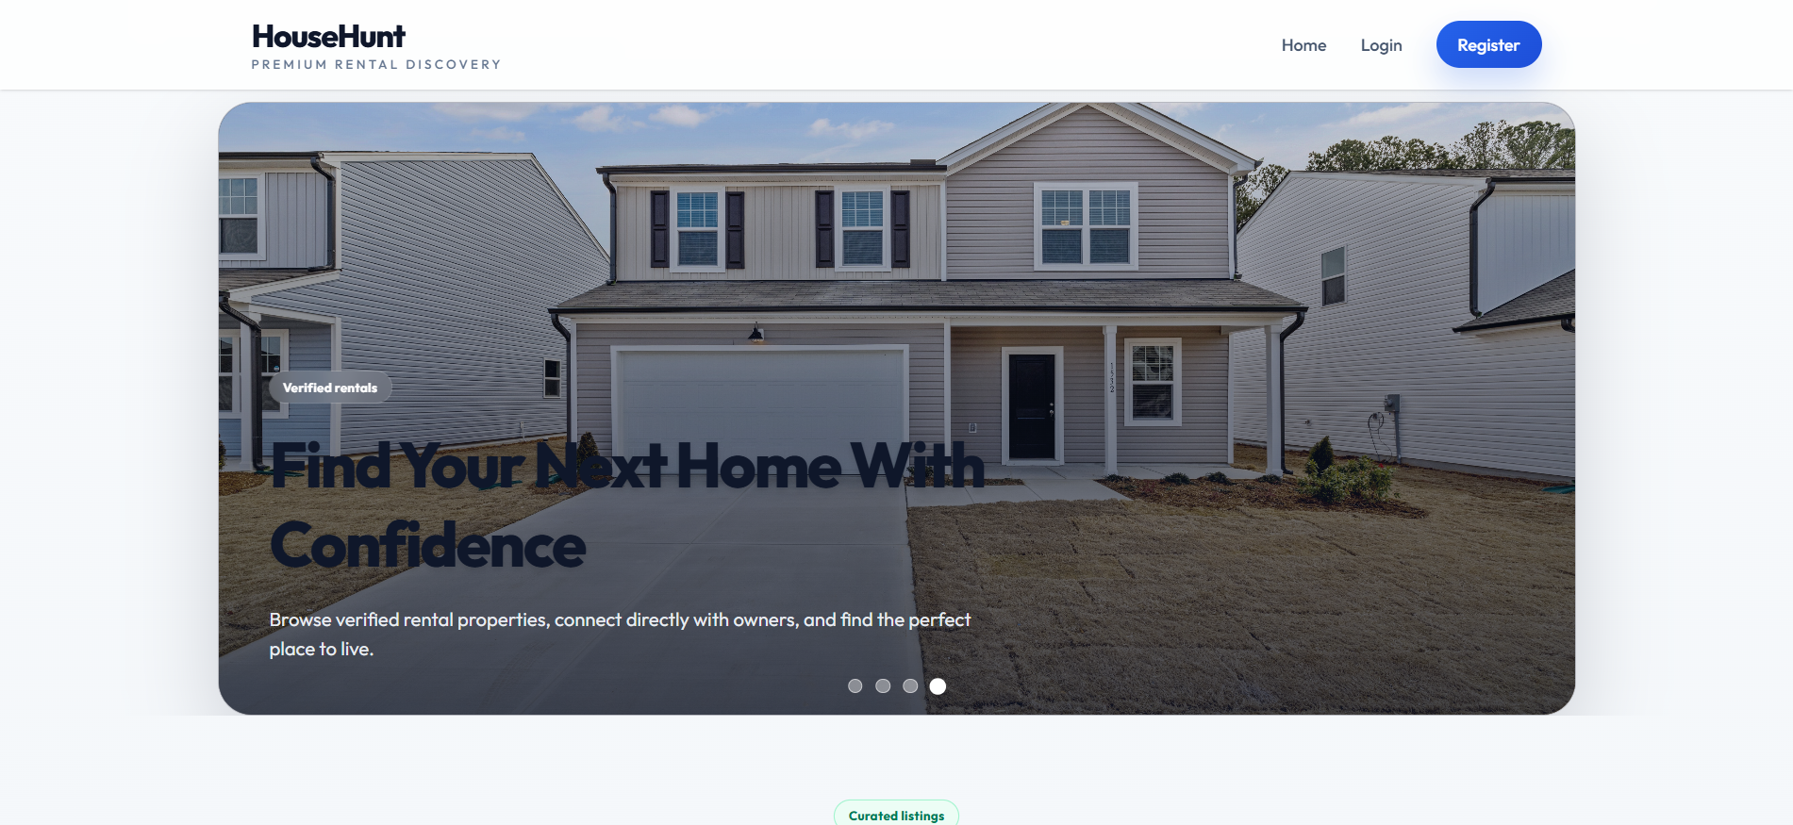
Registration Page:
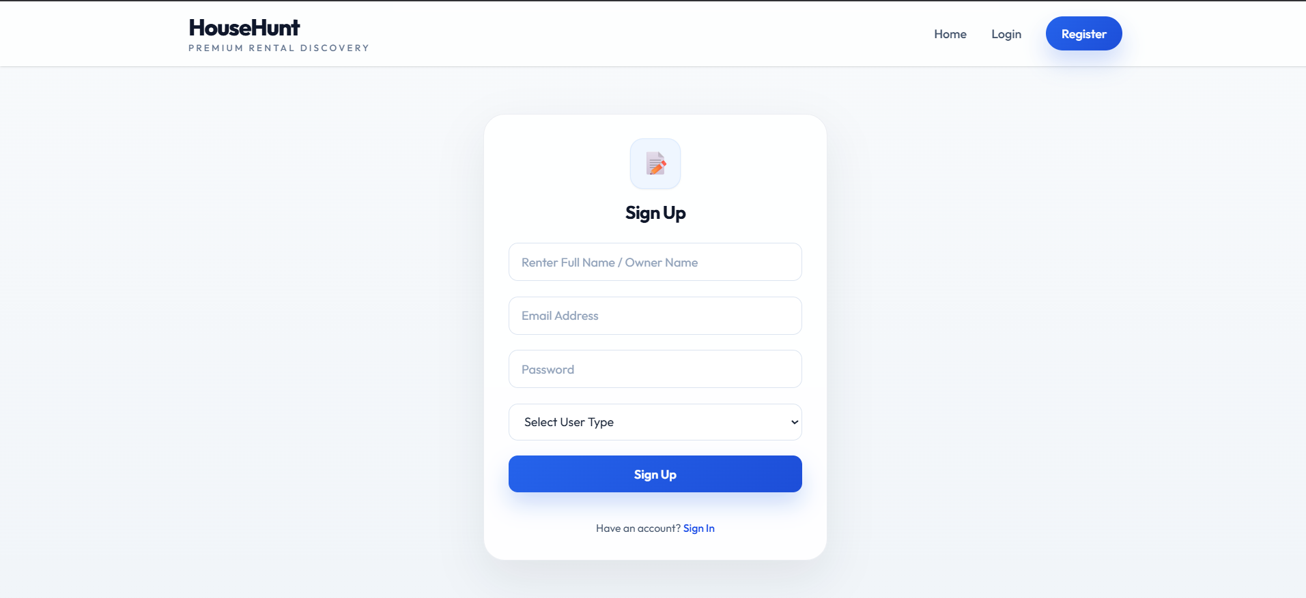
Login Page:
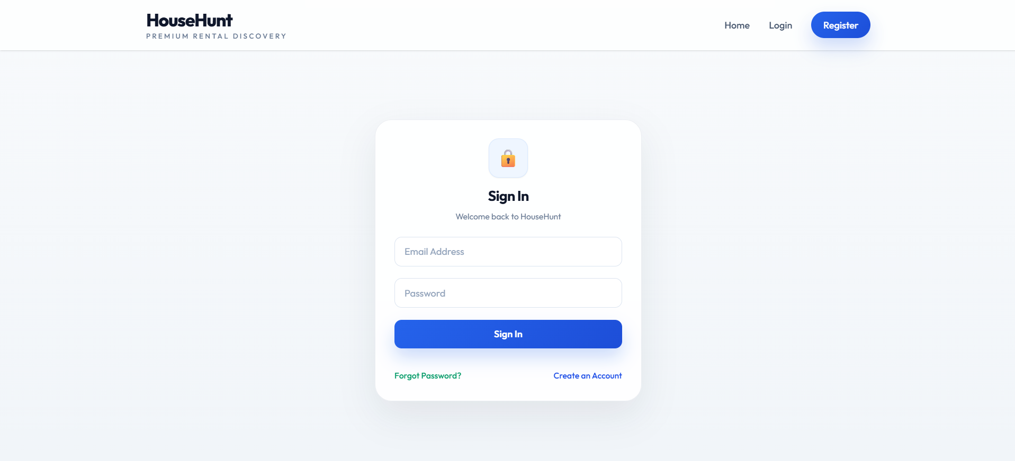
Owner Dashboard:
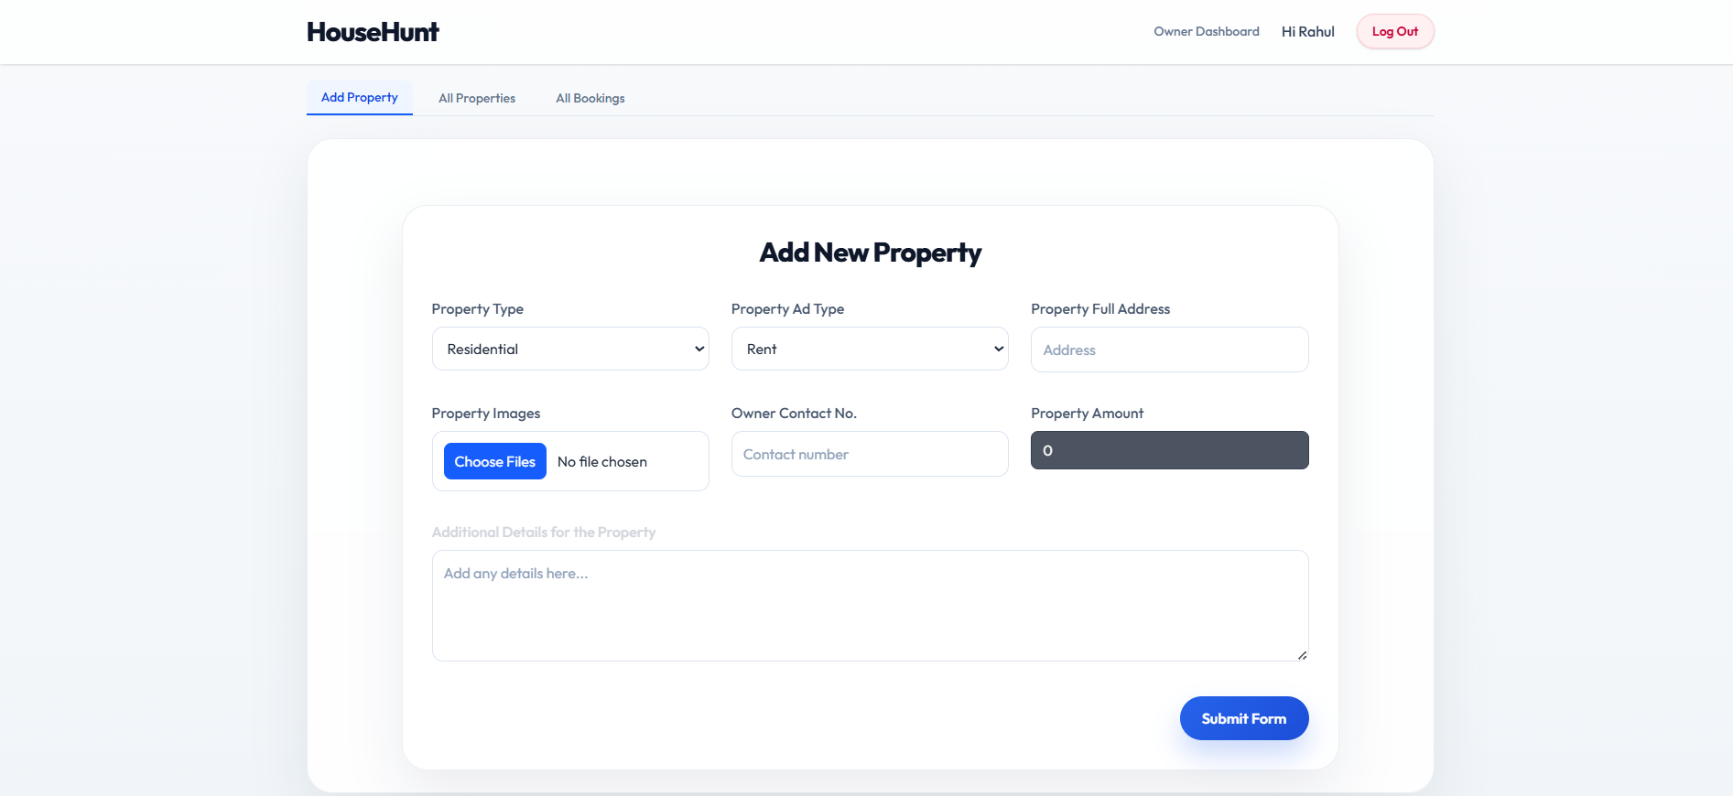
Property Listing Page:
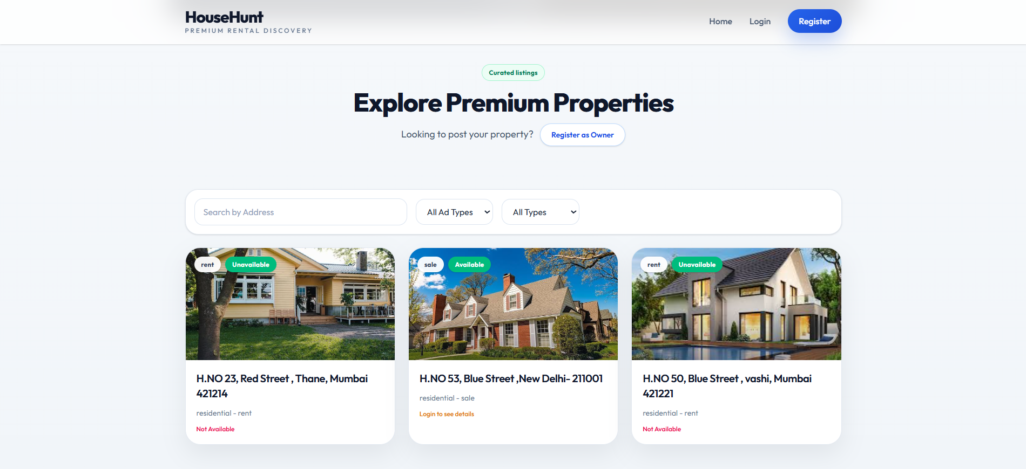
Property Booking Page:
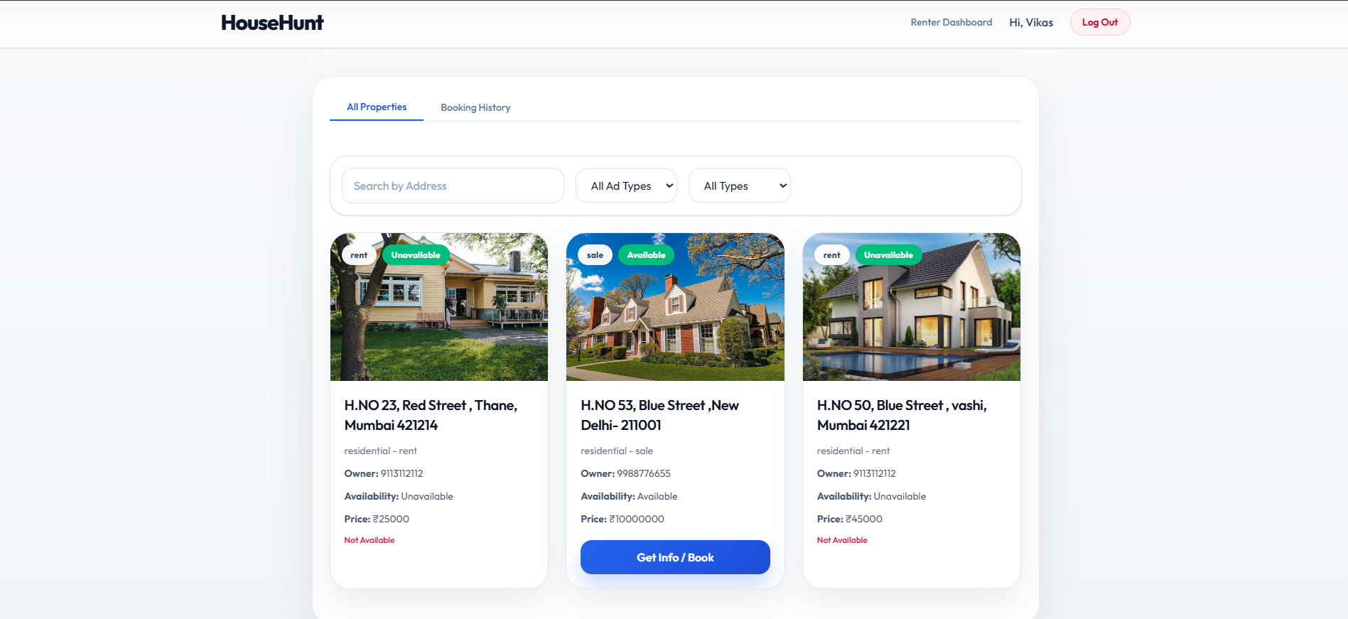
Admin Dashboard:
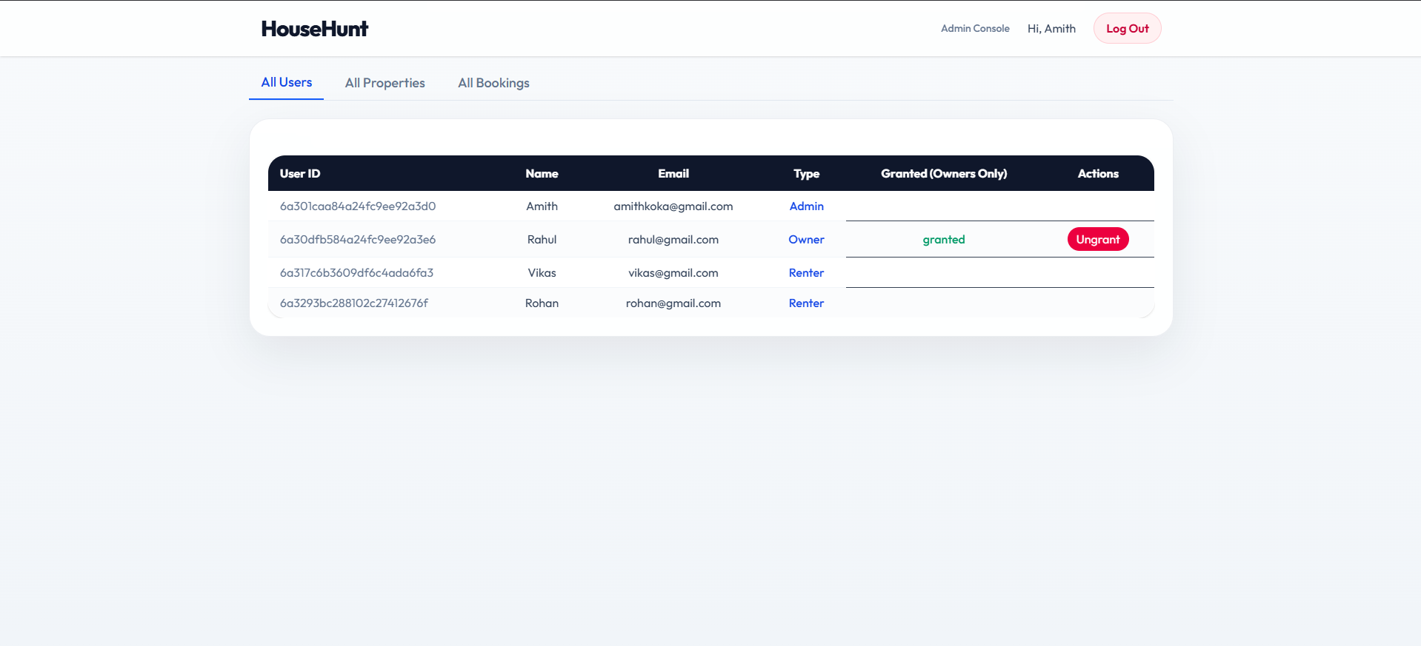
MongoDB Collections:
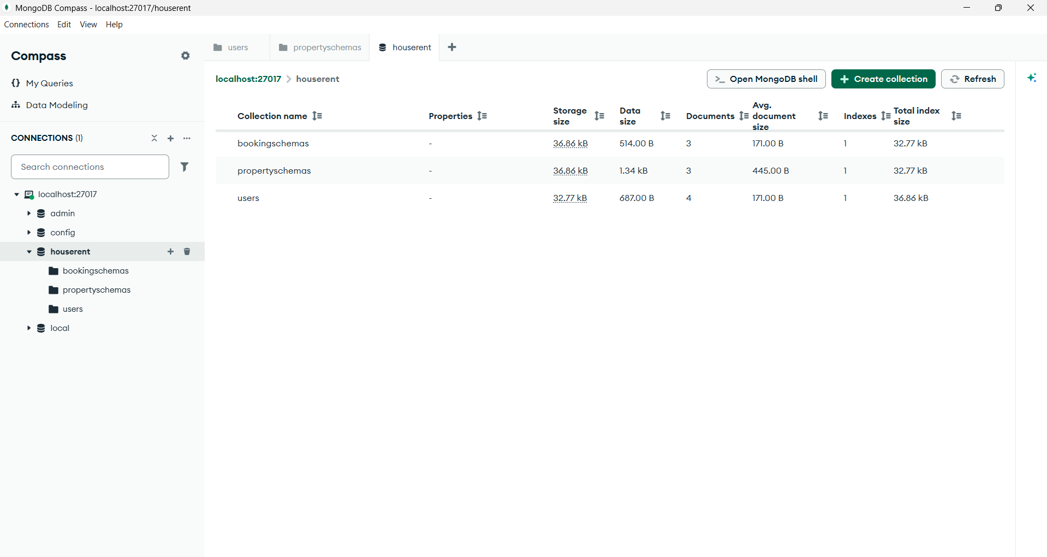
Demo Video Link: https://drive.google.com/file/d/18AIgOdYsqsgxN7842Kdhj6Ke7CJBMOLL/view?usp=drive_link
12. Known Issues
- Multiple Admin registrations are currently possible through the registration form and should be restricted in future versions.
- Image uploads are stored locally and not in cloud storage.
- Email verification is not implemented.
- Password reset uses direct update without email confirmation.
- No payment gateway integration.

13. Future Enhancements
- Cloud Image Storage (AWS S3 / Cloudinary)
- Email Verification System
- Online Rent Payment Gateway
- Property Reviews and Ratings
- Google Maps Integration
- Advanced Search Filters
- Wishlist Functionality
- Real-Time Notifications
- Chat Between Owner and Renter
- Admin Analytics Dashboard

Conclusion
HouseHunt successfully demonstrates a complete MERN Stack application implementing user authentication, property management, booking workflows, and role-based access control. The project provided practical experience in frontend development, backend API creation, database management, authentication, and full-stack integration.

